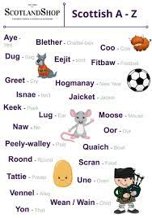 | P6 – Curriculum Overview - Block 3  Heart of Scotland  As always, we’ve kicked off the year with a focus on our wonderful wee hame. We will start the term learning about the Borders and developing our mapping skills using atlases and online maps. We will then move on to learning about Scotland during the Wars of Independence where our focus will be on key individuals, significant events and discovering how people lived in the 13th and 14th century. |  |  | Health & Wellbeing  This term P.E. lessons will focus on different types of fitness, table tennis, basketball skills and other team games.  This term we will celebrate Neurodiversity Week (17th- 23rd March). Prior to this we will continue with our LEANS (Learning About Neurodiversity at School) increasing our understanding of how each of brains is unique and different.  Our ongoing Zones of Regulation and UNCRC (United Nations Convention for the Rights of the Child) rights awareness will continue to be discussed and revisited throughout the term.
Literacy – Reading  In class, time will be given daily for children to read a book of their choice from our extensive class library.  To further promote ‘Reading is Fun’ we will celebrate World Book Day and plan presentations with our children to share their love for a book.  In different reading groups we will continue to work on a range of reading skills and strategies to read and understand texts, for example, skimming, scanning, predicting. This term we will especially focus on inference and summarising.  We will use different types of texts to make notes, organise them under suitable headings and use them to better understand the information. |  | 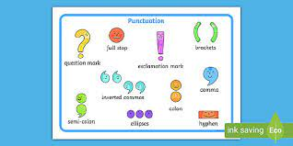  Literacy – Writing  We will continue to investigate more complicated sentence structures by using fronted adverbials, conjunctions and a range of punctuation.  We will start the year by developing our descriptive vocabulary to describe characters, settings and events. We will then go on to use expository writing using our own topic research showing our understanding of finding and organising information. We will use our notes to write an information report, ensuring that our texts are full of useful conjunctions and technical vocabulary.
Literacy – Spelling & Phonics
We will continue with daily spelling lessons which focus on a phoneme, a set of appropriate High Frequency Words or common prefixes, suffixes which can be used to build vocabulary. Our pupils are developing insight into their strengths and challenges for spelling words and are becoming more confident in independently using tools to support themselves when spelling correctly is important.

Literacy – Oracy
P6 are continuing to develop skills in becoming successful talkers and listeners: linguistic, physical, cognitive, social and emotional.
Our Scottish focus, with presentations and recitals, will give us lots of opportunities to build on the physical skills we nurtured throughout the musical: projecting voice, using intonation, eye contact, gesture and facial expression.
To further show their ability and confidence to present, we will ask your child to present a book in front of the class. The preparation for this will be homework. Presentations will be planned in for the first week of March.

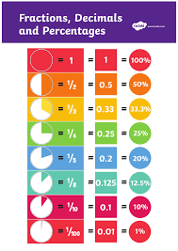  Number  Decimals, Percentages, Fractions  This term we will investigate the everyday contexts in which fractions, percentages or decimal fractions are used.  We will learn the equivalent forms of simple fractions, decimal fractions and percentages.  We will calculate simple fractions of a quantity and use this knowledge to solve problems, for example, find 1/3 of 60. |  |  | 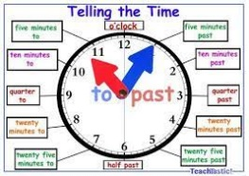  Maths – Time, Properties of Shape, Probability & Chance  We start this block by revisiting time telling by using analogue and digital clocks. We practise to solve real life problems using timetables and calendars.  We will practise identifying and describing 2D and 3D shapes using the correct vocabulary. We will learn the relationship between the radius and the diameter and will use digital technologies to draw a variety of shapes.  We will plan and carry out simple experiments to learn about probability and chance.
Please get in touch if you have any queries, questions or information you feel is important for us to know in order to support your children best.  Mrs Ballantyne – Monday & Tuesday  Mrs Blackie – Wednesday, Thursday & Friday  You can write us a note, call the office and you can also email us:  01835 826533  Edensideps@scotborders.gov.uk |  |  | Science Week  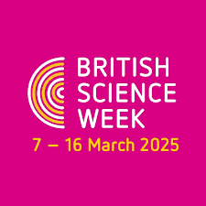  British Science Week is a ten-day celebration of thousands of events running throughout the whole of the UK with the aim of celebrating science, engineering, technology and maths. During this year’s Science Week we will look at Chemical Reactions.

