Numeracy and Maths

Subtraction
We will be learning to:
- Use given strategies to subtract 2-digit numbers (within 30 for some, within 100 for others).
- Subtract 10 to any whole number up to 100.
- Use the correct vocabulary when subtracting.

Shape
We will be learning to:
- Identify and name 2D shapes and 3D objects.
- Use language to describe the properties of 2D shapes and 3D objects, such as side, face, edge and vertex.
- Identify the features of a tiling pattern and create our own tiling pattern.

Money
We will be learning to:
- Identify and use coins and we will explore different ways of making the same amount.
- Record amounts accurately in different ways using the correct notation.
- Use a variety of coin combinations to pay for items.
- Use strategies to calculate a total.
- Understand that goods can be paid for in different ways.

Directions and Angle
We will be learning to:
- Use vocabulary to describe and follow directions, such as full turn, half turn, left, right, forwards, backwards, clockwise and anti-clockwise.
- Use the compass points, North, South, East and West.
- Know what a right angle looks like.
- Compare and describe other angles in relation to a right angle.

Literacy
In reading we will be learning to:
- Recognise an increasing number of sight/common words.
- Use our knowledge of phonics to sound out unfamiliar words
- Identify the beginning, middle, end of a story.
- Read with increasing fluency.
- Show understanding by completing a follow up task.

In writing we will be learning to:
- Consistently use capital letters, finger spaces and full stops in our sentences.
- Use question marks and exclamation marks.
- Develop our fine motor skills which will help us write neatly.
- Use a word bank to spell key vocabulary in our writing.
- Read over our writing to check that it makes sense.
- Include different openers to start sentences.
- Use conjunctions (e.g. and, because) to join sentences together.

Listening and talking
This term, we will use our IDL focus to develop listening and talking skills. We will prepare and deliver a small talk at home to share in school.
We will be learning to:
- Be a respectful listener by looking at the person who is talking.
- Ask open questions to find out more information.
- Take part in group and class discussions.
- Find and discuss interesting vocabulary.

P2/3 Curriculum Overview
January – April 2025
Important Information
Please support your child to be ready for school by:
- Sending their reading folder and reading record to school every day.
- Naming all clothing sent to school.
- Provide a filled water bottle and a healthy snack. This could be fruit, crisps or biscuits but not sweets.
- Providing appropriate outdoor clothing, particularly in the winter months.
- Promoting and practising independence with organising belongings and getting dressed.
- Please discourage your child from bringing toys to school.

Health and Wellbeing:
In P.E. we will be working on developing our fitness skills.
Neurodiversity week: We will learn more about, and celebrate, neurodiversity.
We will also be looking at the following health and wellbeing topics:
- Water safety
- Digital safety
- Personal safety

IDL
This term our IDL focus is Katie Morag. Each week, we will be focusing on a different Katie Morag story.

Katie Morag Delivers the Mail – We will look at the differences between life on the mainland and life on an island. We will set up a post office role play area.
Katie Morag and the two Grandmothers – We will compare two characters.
Katie Morag and the Tiresome Ted – We will prepare and give a talk to the class.
Katie Morag and the New Pier – We will participate in a STEM challenge.

How you can help at home
Promoting Independence
In P2/3, we are promoting resilience, responsibility and independence.
Please encourage and support your child with
- Coats, buttons, shoe laces.
- Using a knife and fork properly.
- Turning inside out clothes the right way round.
- Taking responsibility for their belongings.

Tuck Shop Time  With your child, draw a fun and colourful menu on a sheet of paper showing the snacks on offer and their cost, and give your child a daily allowance to ‘spend’ on snacks from the menu. You could label each item with a different price.  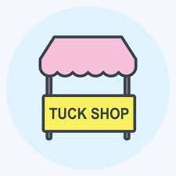 | Money Millipedes  Give your children a handful of small change (or some toy coins if you have them) and some paper and coloured pencils. Ask them to draw around the coins in rows of up to six coins, writing their values in each coin. Ask your child to calculate the total value of the coins.  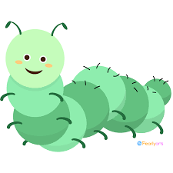 | Chat about money  Most people do not use coins and notes when visiting a shop or spending money. Talk with your child about how you spend money and give them opportunities to explore different ways to spend money.  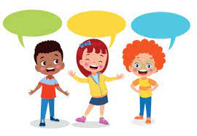
We are learning about money this term. Here are some ideas for ways you can support your child’s learning at home.

